**JUnit Testing Exercises**

Exercise 1: Setting Up JUnit Scenario: You need to set up JUnit in your Java project to start writing unit tests.

**Objective**

To set up JUnit in a Java project using Maven and implement a basic unit test for a Calculator class method.

Coding:

Dependencies:

Pom.xml

<project xmlns="http://maven.apache.org/POM/4.0.0"

xmlns:xsi="http://www.w3.org/2001/XMLSchema-instance"

xsi:schemaLocation="http://maven.apache.org/POM/4.0.0

http://maven.apache.org/xsd/maven-4.0.0.xsd">

<modelVersion>4.0.0</modelVersion>

<groupId>com.example</groupId>

<artifactId>JUnitExample</artifactId>

<version>0.0.1-SNAPSHOT</version>

<dependencies>

<dependency>

<groupId>junit</groupId>

<artifactId>junit</artifactId>

<version>4.13.2</version>

<scope>test</scope>

</dependency>

</dependencies>

</project>

Calculator.java

package com.example;

public class Calculator {

public int add(int a, int b) {

return a + b;

}

}

CalculatorTest.java

package com.example;

import static org.junit.Assert.*assertEquals*;

import org.junit.Test;

public class CalculatorTest {

*@Test*

public void testAdd() {

Calculator calc = new Calculator();

int result = calc.add(5, 3);

*assertEquals*(8, result);

}

}

Output:

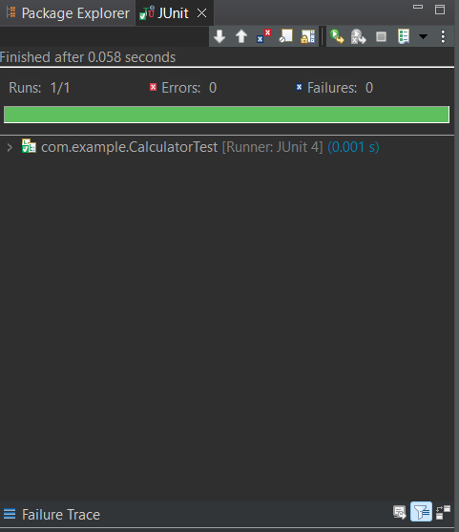

Exercise 3: Assertions in JUnit Scenario: You need to use different assertions in JUnit to validate your test results.

**Objective**

To set up Apache Maven and configure JUnit in a Java project for unit testing using Eclipse. This includes installing Maven, configuring environment variables, adding dependencies, and writing a test class using JUnit assertions.

Coding:

Pom.xml

<project xmlns="http://maven.apache.org/POM/4.0.0"

xmlns:xsi="http://www.w3.org/2001/XMLSchema-instance"

xsi:schemaLocation="http://maven.apache.org/POM/4.0.0

http://maven.apache.org/xsd/maven-4.0.0.xsd">

<modelVersion>4.0.0</modelVersion>

<groupId>com.example</groupId>

<artifactId>JUnitTestExample2</artifactId>

<version>0.0.1-SNAPSHOT</version>

<dependencies>

<dependency>

<groupId>junit</groupId>

<artifactId>junit</artifactId>

<version>4.13.2</version>

<scope>test</scope>

</dependency>

<dependency>

<groupId>org.hamcrest</groupId>

<artifactId>hamcrest</artifactId>

<version>2.2</version>

<scope>test</scope>

</dependency>

</dependencies>

</project>

AssertionsTest.java

package com.example;

import static org.junit.Assert.*;

import org.junit.Test;

public class AssertionsTest {

*@*Test

public void testAssertions() {

// Assert equals

assertEquals(5, 2 + 3);

// Assert true

assertTrue(5 > 3);

// Assert false

assertFalse(5 < 3);

// Assert null

assertNull(null);

// Assert not null

assertNotNull(new Object());

}

}

Output:

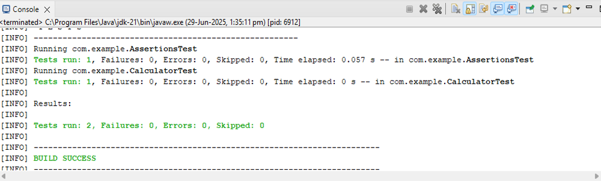

Exercise 4: Arrange-Act-Assert (AAA) Pattern, Test Fixtures, Setup and Teardown Methods in JUnit Scenario: You need to organize your tests using the Arrange-Act-Assert (AAA) pattern and use setup and teardown methods.

Coding:

Pom.xml

<project xmlns="http://maven.apache.org/POM/4.0.0"

xmlns:xsi="http://www.w3.org/2001/XMLSchema-instance"

xsi:schemaLocation="http://maven.apache.org/POM/4.0.0

https://maven.apache.org/xsd/maven-4.0.0.xsd">

<modelVersion>4.0.0</modelVersion>

<groupId>com.example</groupId>

<artifactId>JUnitCalculatorExample</artifactId>

<version>1.0-SNAPSHOT</version>

<dependencies>

<!-- JUnit 4 Dependency -->

<dependency>

<groupId>junit</groupId>

<artifactId>junit</artifactId>

<version>4.13.2</version>

<scope>test</scope>

</dependency>

<!-- Hamcrest for better assertions (optional but recommended) -->

<dependency>

<groupId>org.hamcrest</groupId>

<artifactId>hamcrest</artifactId>

<version>2.2</version>

<scope>test</scope>

</dependency>

</dependencies>

</project>

Calculator.java

package com.example;

public class Calculator {

public int add(int a, int b) {

return a + b;

}

public int subtract(int a, int b) {

return a - b;

}

}

CalculatorTest.java

package com.example;

import static org.junit.Assert.*;

import org.junit.Before;

import org.junit.After;

import org.junit.Test;

public class CalculatorTest {

private Calculator calculator;

// Setup method - runs before each test

@Before

public void setUp() {

calculator = new Calculator();

System.out.println("Setup: Calculator instance created.");

}

// Teardown method - runs after each test

@After

public void tearDown() {

calculator = null;

System.out.println("Teardown: Calculator instance destroyed.");

}

@Test

public void testAddition() {

// Arrange

int a = 5;

int b = 3;

// Act

int result = calculator.add(a, b);

// Assert

assertEquals(8, result);

}

@Test

public void testSubtraction() {

// Arrange

int a = 10;

int b = 4;

// Act

int result = calculator.subtract(a, b);

// Assert

assertEquals(6, result);

}

}

Output:

